Enrol: ___________________NSN: ____________________ SMS: ___________________



RĀNUI PRIMARY SCHOOL
PUPIL ENROLMENT FORM

Surname: _________________________________

First Name(s): ___________________________________________________

D.O.B.:_________________ Gender: M / F Age as at 1st Jan: _____________

Street: __________________________________________ Suburb: ____________________ Phone Number: ___________________

Previous School: _______________________ Previous Year: ______________ Previous School Suburb / Area: __________________

Pre Schooling at: _____________________________ Duration: _____________ Hippy Yes / No

CHILDREN ARRIVED FROM OVERSEAS | Date of Entry to NZ: _____________ Country Born In: __________________  Country of Residence: ________________ Permit Type: __________________  Number:____________ Expiry Date: ____________________ | E.S.O.L. Eligibility:  YES / NO
FAMILY AND EMERGENCY DETAILS | Mother’s Name: ______________________________  Father’s Name: _________________________________________  Lives With: ______________________________________ Legal Guardian: _________________________  Legal Custody Conditions: _____________________________________ Legal Documentation Given Yes/No  Separated Parent’s Address and Phone Number:  ______________________________________________________________________  Mother’s Occupation: ______________________ Place of Work: ____________________________  Work Phone: ________________ Cell Phone: __________________________  Mother’s Ethnicity: _______________________ Country of Birth: _________________________  Father’s Occupation: _______________________ Place of Work: ____________________________  Work Phone: ________________ Cell Phone: __________________________  Father’s Ethnicity: ______________________ Country of Birth: _______________________  Home Languages: _____________________________________________  Maori Bi-Lingual Enrolment: YES / No IWI: __________________________________________  Samoan Bi-Lingual Enrolment: YES / No  Emergency Contact:  Name: ____________________________ Relationship: _________________ Phone: ________________  Name: ____________________________ Relationship: _________________ Phone: ________________
FAMILY AND EMERGENCY DETAILS | Place in Family: _______________ Name of Eldest Child at Ranui: _______________________  Names of Younger Siblings Yet to Attend School:  _______________________________ D.O.B. _________________  _______________________________ D.O.B. _________________  _______________________________ D.O.B. _________________  _______________________________ D.O.B. _________________
HEALTH NOTES | Sight / Hearing / Speech Comments: ______________________________________________________  Allergies: ____________________________________ Medication: ________________________________  Conditions: ____________________________________ Medication: ________________________________  Doctor: ___________________________ Phone: _____________  Additional Information Offered by Parents: (Religion, Learning or Behaviour):
OFFICE USE ONLY | Birth Certificate Sighted: Yes / No Passport Sighted: Yes / No Immunization Certificate Sighted: Yes / No  To Room: ____________ Start Date: ________________ Class Level: ____________ Teacher: _______________

Agreements and Permissions:
- I agree that the school will take action on my behalf in case of sudden illness or injury of my child;
- I agree to abide by the school’s policies;
- I give permission for my child to undertake visits/trips outside the classroom, within the surrounding area of Rānui. Transport may include travel by bus, train or car, or by walking if in close proximity to the school.

*In terms of the Privacy Act:
- I understand that the Ministry of Education shares information about five year olds enrolled in school with Ministry of Health professionals as part of the B4 School Check Ministry of Health initiative and the collection of ECE data.
- I agree that my child’s work and image may be used in accordance with the school’s online publishing policy procedures;
- I approve the forwarding of school records and information when my child transfers to another school;
- I approve the forwarding of my child’s name and address to a potential Intermediate School.

SIGNED: ____________________________________________

RĀNUI PRIMARY SCHOOL

What do you expect from Rānui?

Before School Experiences

Learning Support
(Levels, Interests & Strengths, Needs & Concerns, Learning & Behaviour)

Other Support

Technology in the home

Other Information

Application Checklist (Office Only)

WE REQUIRE ALL DOCUMENTATION BEFORE WE CAN ACCEPT AND PROCESS THE APPLICATION. OTHER DOCUMENTATION MAY BE REQUESTED TO SUPPORT THE ENROLMENT.

Check before processing | Parent Use | Office Use
Enrolment received by:
Signature:
Date:
Fully completed enrolment form
Birth certificate/Passport sighted and copied
Bring original (school will copy)
Ethnicity details completed
Citizenship details completed
If not a New Zealander Citizen, appropriate Student Visa must be provided (school will copy)
Parental Permission
Early Childhood Attendance
Annual Consent/Rumaki Consent
Cybersafety Agreement
Hearing & Vision form returned
Immunisation record
Parent Signed
Transition Visits if applicable
Copies to:
Class Teacher
Hub Leader
ESOL/SENCO
Library
ICT

Home Zone

The Ministry of Education is proposing an enrolment scheme for Rānui School, which will be in effect for the beginning of term 2 in 2023. Having an enrolment scheme in place will ensure the Board of Trustees has a fair and transparent mechanism to manage the roll as it grows. Children that live within this area will have entitlement to enrol at Ranui School. The home zone area is shown on the map below and includes:
Starting at the intersection of Luanda Drive and Armada Road, head east along Luanda Drive (49-67 odd addresses included) until Waitemata Road. Head southeast along Waitemata Road (156-206 even addresses, 155 addresses included) until Swanson Road.
Following Swanson Road (229-529 odd addresses, 302-532 even addresses) east until Metcalfe Road:
- Afton Place included
- Muriel Place included
- Don Buck Road (1-29A odd addresses, 2-14 even addresses included)
- Rakich Place (13-65 odd addresses, 24-38 even addresses included)
- Sun Place included
Heading southwest along Metcalfe Road (1-179 odd addresses, 2-132 even addresses and all no exit roads included) until Ranui Station Road:
- Pooks Road included
- Ranui Ave included
- Ilana Place included
- Jillian Drive included
- Clearview Heights included
- Kahikatea Place included
Travel west along Ranui Station Road (both sides, Carlas Way, Robertson Road, Arney Road included) until Swanson Road. Follow Swanson Road west until Luanda Drive and head north up Luanda Drive (both sides and all no exit roads included) back to the starting point.
* Proof of residence within the home zone will be required.
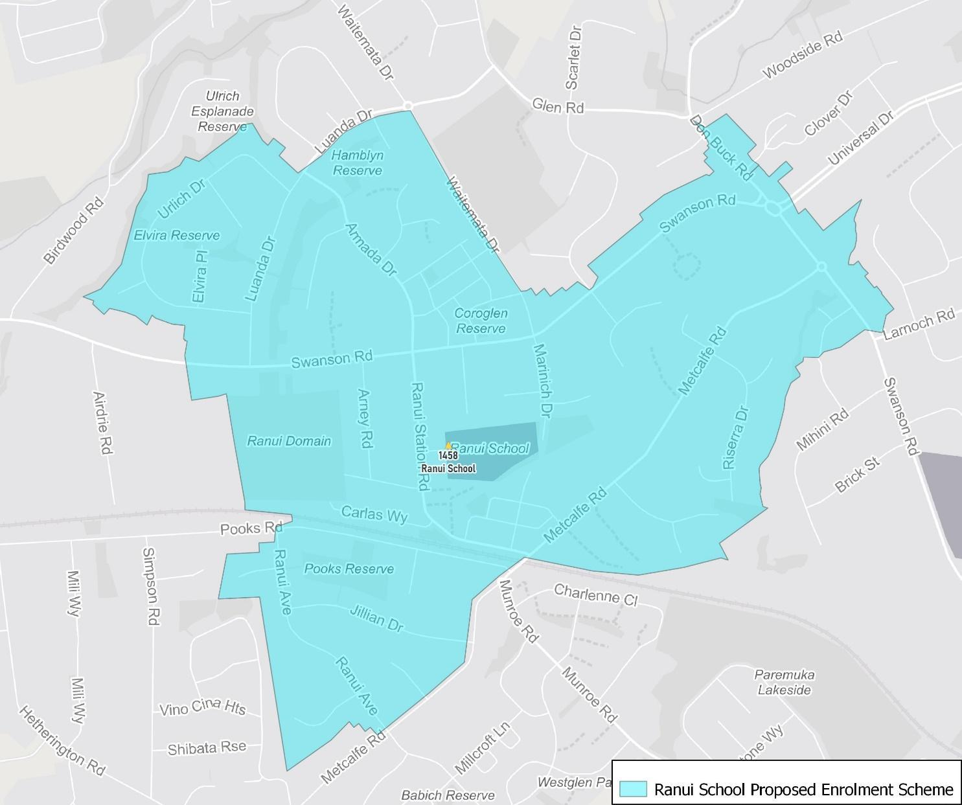



RĀNUI SCHOOL IN-ZONE STATUTORY DECLARATION

IMPORTANT INFORMATION FROM THE MINISTRY OF EDUCATION

The address given at the time of application for enrolment must be the students usual place of residence when the school is open for instruction. This means that if you currently live at an in-zone address, but move to an out-of-zone address before your child/ren’s first day of attendance, your child/ren will not be entitled to enrol at the school.
The Ministry of Education has also advised that parents should be warned of the possible consequences of deliberately attempting to gain unfair priority in enrolment by knowingly giving a false address or making an in-zone living arrangement which they intend to be only temporary e.g:
- renting accommodation in-zone on a short-term basis;
- arranging temporary board in-zone with a relative or family friend;
- using the in-zone address of a relative or friend as an “address of convenience”, with no intention to live there on an ongoing basis.
If the school learns that a student is no longer living at the in-zone address given at the time of application for enrolment and has reasonable grounds to believe that the temporary in-zone residence has been used for the purpose of unfairly gaining priority in enrolment at the school, then the board may review the enrolment. Unless the parents can give a satisfactory explanation within 10 days, the board may annul the enrolment. This course of action is provided for under section 110a of the Education Act 1989.
PARENT INFORMATION
- Children attending Rānui School are expected to adhere to school rules, policies and procedures.
- It is compulsory to wear the Rānui School uniform.
- All parents/caregivers are encouraged to provide support to the school through a variety of ways including assisting with: camps and trips.
- All children are required to arrive on time for school (between 8.15am and 8.50am). The morning bell to start school will ring at 8.55am. Any absence or lateness is to be notified by a parent/caregiver - please phone the school and leave a message on (09)833-6286, text (022)1083975 or email office@ranui.school.nz
- All parents/caregivers are required to provide accurate information to the school on enrolment and update immediately when details may change.
- In signing the application for enrolment, I understand that the information in this application, and other information and records maintained by the school relating to the child is personal information, and authorize the school to keep, use and disclose such personal information for any purpose the school considers necessary.

I, _________________________________________________________________________(parent/caregiver name)

am the parent/caregiver of __________________________________________________________(child/ren name)

DO SOLEMNLY AND SINCERELY DECLARE that the above named child permanently resides at the following address,

______________________________________________________________________________________(address)
RĀNUI SCHOOL OUT-OF-ZONE STATUTORY DECLARATION

OUT-OF-ZONE STUDENTS PARENT INFORMATION

- Children attending Rānui School are expected to adhere to school rules, policies and procedures.
- It is compulsory to wear the Rānui School uniform.
- All parents/caregivers are encouraged to provide support to the school through a variety of ways including assisting with: camps and trips.
- All children are required to arrive on time for school (between 8.15am and 8.50am). The morning bell to start school will ring at 8.55am. Any absence or lateness is to be notified by a parent/caregiver - please phone the school and leave a message on (09)833-6286, text (022)1083975 or email office@ranui.school.nz
- All parents/caregivers are required to provide accurate information to the school on enrolment and update immediately when details may change.
- In signing the application for enrolment, I understand that the information in this application, and other information and records maintained by the school relating to the child is personal information, and authorize the school to keep, use and disclose such personal information for any purpose the school considers necessary.

Checklist:
This application WILL NOT be accepted unless the following documentation is included:

- If you are not a NZ resident you must provide the parent/caregiver and child's passport (the school will photocopy).
- Original birth certificate for any child/ren entering the school on his/her fifth birthday (school will photocopy).
- For children born from 1 January 1995 we are required by law under the Health (Immunization) Regulations 1995 to sight that child's immunization certificate.

DECLARATION

I, Mr / Mrs / Miss / Ms _____________________________________________________________ have read the above
and understand all of the points made.

PARENT/CAREGIVER SIGNATURE: ____________________________________________ DATE: _____________________

Out-of-Zone Enrolments
Each year the board will determine the number of places which are likely to be available in the following year for the enrolment of students who live outside the home zone. The Board will publish this information by notice in a daily or community newspaper circulating in the area served by the school. The notice will indicate how many applications are to be made and will specify a date by which all applications must be received. Applications for enrolment will be processed in the following order of priority:
First Priority: will be given to Rumaki applicants who meet the criteria set for the special programmes at Rānui School. However, the priority category is not applicable at this school until these programmes are approved by the secretary.
Second Priority: will be given to applicants who are siblings of current students.
Third Priority: will be given to applicants who are siblings of former students.
Fourth Priority: will be given to applicants who are children of employees of the school’s Board.
Fifth Priority: will be given to all other applicants.

If there are more applicants in the second, third, fourth or fifth priority groups than there are places available, selection within the priority group will be ballot conducted in accordance with instructions issued by the Secretary under Section 11G(1) of the Education and Training Act 2020. Parents will be informed of the date of any ballot by notice in a daily or community newspaper circulating in the area served by the school. Applicants seeking second or third priority status may be required to give proof of a sibling relationship.
Special Programmes
Te Whakatipu Kākano is a level 1 bilingual Te Reo Māori Immersion Unit. Te Whakatipu Kākano is a Bilingual Whānau catering for tamariki from years 1-6. We have junior, middle and senior classes. Te Whakatipu Kākano refers to the growing seed. It is a place where everyone can grow and develop, as strong and in as many directions as they are able. The tamariki are nurtured in a supportive whānau atmosphere which encourages the following values- Te Reo Māori me ona tikanga- to value and use Te Reo Māori and customs.

Criteria for Special Programme
Before children are accepted and part of the enrolment process, students and Whānau must attend a special programme enrolment interview where they will be scored regarding the following criteria:
- applicants who are descendants of Te Kawerau a Maki
- applicants who are siblings of current students
- applicants who are siblings of former students
- applicants who are tamariki of former students
- applicants who have attended a Kōhanga Reo
- applicants whose first language is Te Reo Māori

ENROLMENT TIMELINE FOR 2024 APPLICATIONS
Rānui School will publish a public notice by… 15th September
Out-of-Zone applications close | Friday 13th October
Out-of-Zone Ballot | Friday 20th October
Acceptances Out-of-Zone Ballet | Friday 27th October

Ranui Primary School



Internet Agreement

Terms and conditions of use

- The school network is available for the learning to use the computer and for research work related to school.
I will NOT use it for private internet, e-mail or non–school related activities.
- I agree not to access unsuitable, offensive or illegal material. This includes any material that is pornographic, racist, sexist, unethical, obscene, sexual or violent in nature.
If I come across such material by accident I will:
- close the material or programme down, (or turn off the monitor), so no one else can see it
- tell my teacher immediately
- tell the Principal immediately
- not tell other students about it or where it was found.

- I will not access web based email accounts from the school computers. If I wish to transfer school work home, I will arrange for my class teacher to email it on my behalf. Where appropriate I will use the schools office email to send or receive emails pertaining to school studies. I will be supervised by an adult when sending emails.

- I will not bully another person using email, internet or computer facilities.

- I will not swear, use vulgar or inappropriate language on the school computer network.
- I will not share anybody's home address or phone numbers on the network. I understand that email is not private and may be read by the principal or other staff. I understand that I am not allowed to group email addresses, unless specifically asked by a teacher to do so.

- I will not use the network in a way that is disruptive to others.

- I will not intentionally seek information, obtain copies, delete or change information belonging to other users of the network.
- I will not copy information from the internet and present it as my own work. For any assessed piece of work I will rewrite all the information in my own words and reference where I got the information from.

- I understand that if I try to gain unauthorised access to system programs or computer equipment the privileges of computer use will be withdrawn, and my parents contacted. If I become a security risk or have a series of problems with the network I will be denied access to the school computers for a specified period.

- I understand that any vandalism of school computing equipment will involve the cancellation of privileges to be followed by the usual consequences for breaking school rules. The school may look to recover the costs from my parents or caregivers. (For this document vandalism is defined as any malicious attempt to harm, modify or destroy computer hardware, software or data at Ranui Primary School.)

- I understand that my classroom teacher has access to all pupil files and is able to check my computer usage.
- I understand that if I break any of these rules that my computer privileges may be suspended for a period of time and that my parents, and possibly the police, may be contacted.

Ranui Primary School

Ranui Primary School Digital Technology & Online Safety Agreement

Terms and Conditions of Use

Student

Name ________________________________________________ of Room _________________

I have read, understood and agreed to the terms and conditions of the Ranui Primary School Computer and Internet Agreement.

Student signature________________________________________ Date ______________

Parent or Caregiver

As the parent or caregiver of this student I have read the Ranui School Computer and Internet Agreement and agree to the conditions contained within it. I understand that this access is designed for educational purposes and that Ranui Primary School has taken precautions where available to eliminate controversial material. I recognise it is not possible to restrict access to all controversial material and I will not hold the school responsible for material accessed by my child on the computers. I give permission for my child to use the Internet for research associated with class work, to publish his / her own work, to send and receive email, and I accept responsibility for his / her use. I understand that if the guidelines are not followed that school disciplinary and / or legal action may be a result of this action.

Parent / Guardian Signature _______________________________________________ Date ___________

Here are 2 guidelines to help students remember the rules:

- The school computers are for school work only.
2 .Would I be happy for my parents and teacher to see what I am doing on the computer? If not, don’t do it!

Please sign above and return to Ranui Primary School.

